To simulate unstable signal conditions in a mobile scenario, we conducted two experiments based on the experimental environment described in Section VI.A.

The first experiment involved introducing a delay in the identity authentication process at the UE side to simulate data delay.

The second experiment involved selecting frequency bands for communication between the UE and gNB in a band with more signal interference, thereby increasing the noise affecting their communication.

In the first experiment, when the UE receives the (R, AUTN, SNMAC) sent by the SN, if the UE delays sending the message to the gNB by 5ms, the core network will start the T3560 timer. However, since the delay is short, it does not time out, and the protocol proceeds normally (as shown in Figure1).

If the UE delays sending the message to the gNB by 1 minute, the core network will start the T3560 timer, but due to the prolonged absence of messages from the UE, the authentication process terminates, and the core network sends a command to release the UE context to the gNB (as shown in Figure2), leading to connection release.

Reconnecting will require re-authentication.

In the second experiment, the downlink Absolute Radio Frequency Channel Number (ARFCN) of the gNB was set to 368500, while the corresponding downlink ARFCN of the UE was set to 2850.

At this point, the gNB would receive interference from various signals, leading to high overflow (as shown in Figure3).

Additionally, there may be situations where the UE would not receive any message from the gNB after sending a registration request message (as shown in Figure4).

However, once the UE was able to receive messages from the gNB, it would successfully send the computed messages back to the gNB, which would then be authenticated by the core network.

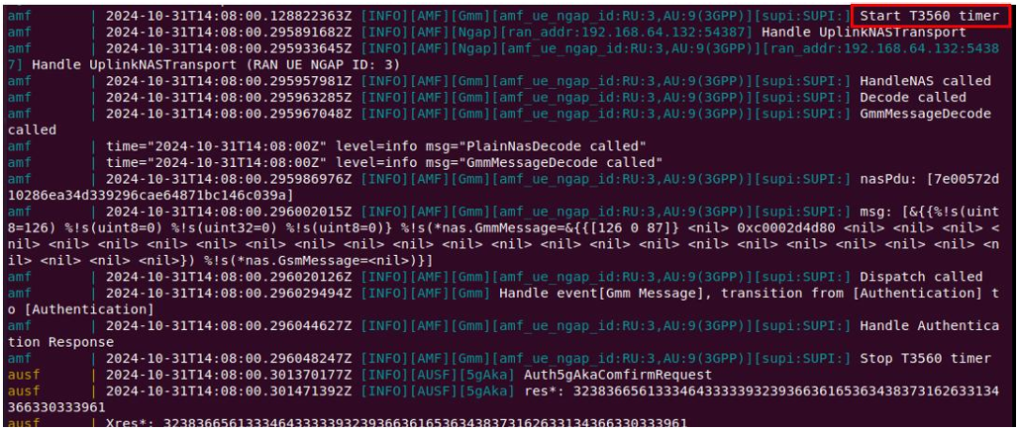

Figure 1

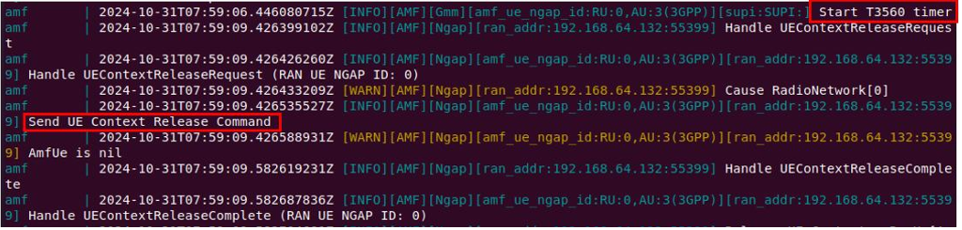

Figure2

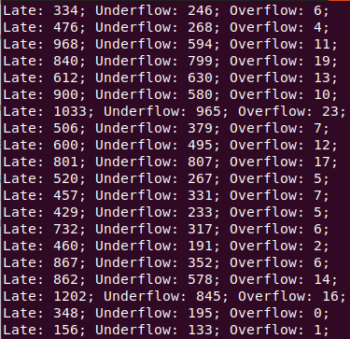

Figure3

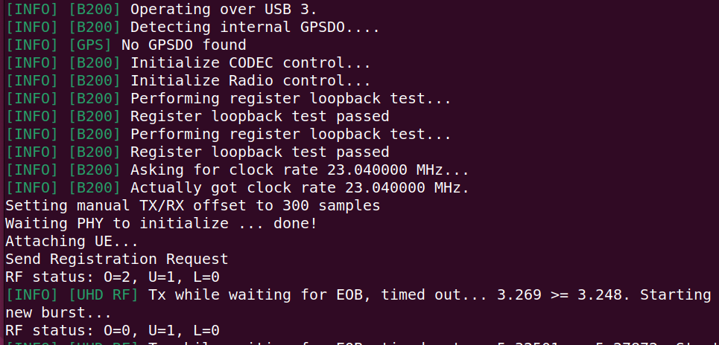

Figure4

Through the above two experiments, we found that signal instability caused by mobile scenarios can lead to the failure of normal connection establishment, which can affect the normal execution of the protocol.